Basic Drug Awreness Training Workbook
Course Aims:
- Drugs and drug use in context – a brief history
- Attitudes to drugs and drug users
- Commonly used drugs, their effects and relative harms.
- Clarify terms- what does ‘use’, ‘problem use’, ‘dependency’, ‘tolerance’, ‘withdrawal’, ‘addiction’, ‘harm reduction’, ‘dependency’ and ‘recovery’ mean?
- Responses, resources and Interventions available
Your Priorities:
What do you want from the course?
Your level of confidence with the subject matter? 0(none) – 10 (complete)
Choose a rating and explain why you rate yourself as such and what would help build your confidence:

What is a drug? (notes)

A short history of drugs:
- The opium poppy - 5000–4000 BC
- 400 BC ancient Greeks used opium widely
- 16th Century COFFEE is introduced to UK and TOBACCO ARRIVES IN BRITAIN
- 1720- 1751 The Gin ‘Epidemic’ (inc1736 The Gin Act)
- 1798 SYRINGE INVENTED
- 1839-1860 The Opium Wars
- 1868 – Pharmacy Act
- 1898 Heroin becomes available as a pharmaceutical product
- 1908 – Poisons and Pharmacy Act
- 1920 Dangerous Drugs Act then 1925 – Dangerous Drugs Act. Controlled importation of coca leaf and cannabis
- 1926 HEROIN ON THE STATE - The Rolleston committee decided to is a medical condition and that there were circumstances in which heroin addicts should be given the drug on prescription
- 1926 METHADONE PATENTED
- 1928 – Amendment to Dangerous Drugs Act criminalising possession of cannabis
- 1938 LSD First produced
- 1943 Valium and Librium, the first benzodiazepines
- 1964 The Drugs (Prevention of Misuse) Act –amphetamines
- 1964 – Dangerous Drugs Act, following UN 1961 Single Convention. Includes criminalising cultivation of cannabis.
- 1964 - Drugs (Prevention of Misuse Act) criminalised possession of amphetamines.
- 1968 The Medicines Act. RISING HEROIN USE
- 1971 The Misuse of Drugs Act - introduces Scedules of drugs and penalties; ACMD established;
- 1982 ACMD Treatment report
- 1986 Drug Trafficking Offences Act
- The 2000’s – lots of drugs legislation! Predominantly criminal justice
Notes:

Can you think of any other great drug users in history?

Attitudes
Exercise
Pick a substance you have chosen or decided not to use:
What information led you to make that decision?
How credible did you find the source?

Attitudes to Drugs and Drug Users
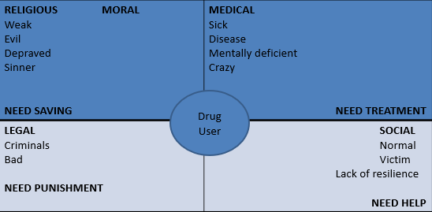
Notes:

Drugs and Their Effects
Exercise
Put all the drugs you know into the following categories:
Depressants: | Stimulants: |  | Hallucinogens:
Volatile Substances: |  | Others:

Drugs information and Harm and Reduction
Notes:

Risks and Relative Harm
Exercise
Put the following drugs into a list with the most harmful at the top and least at the bottom?
Amphetamines
Heroin
Alcohol
Psychedelic mushrooms
Ecstasy
Benzodiazepines
Cannabis
Tobacco
LSD
Cocaine

What Affects the Effect?
Notes:

Drugs and the Law
Notes:

Novel Psychoactive Substance
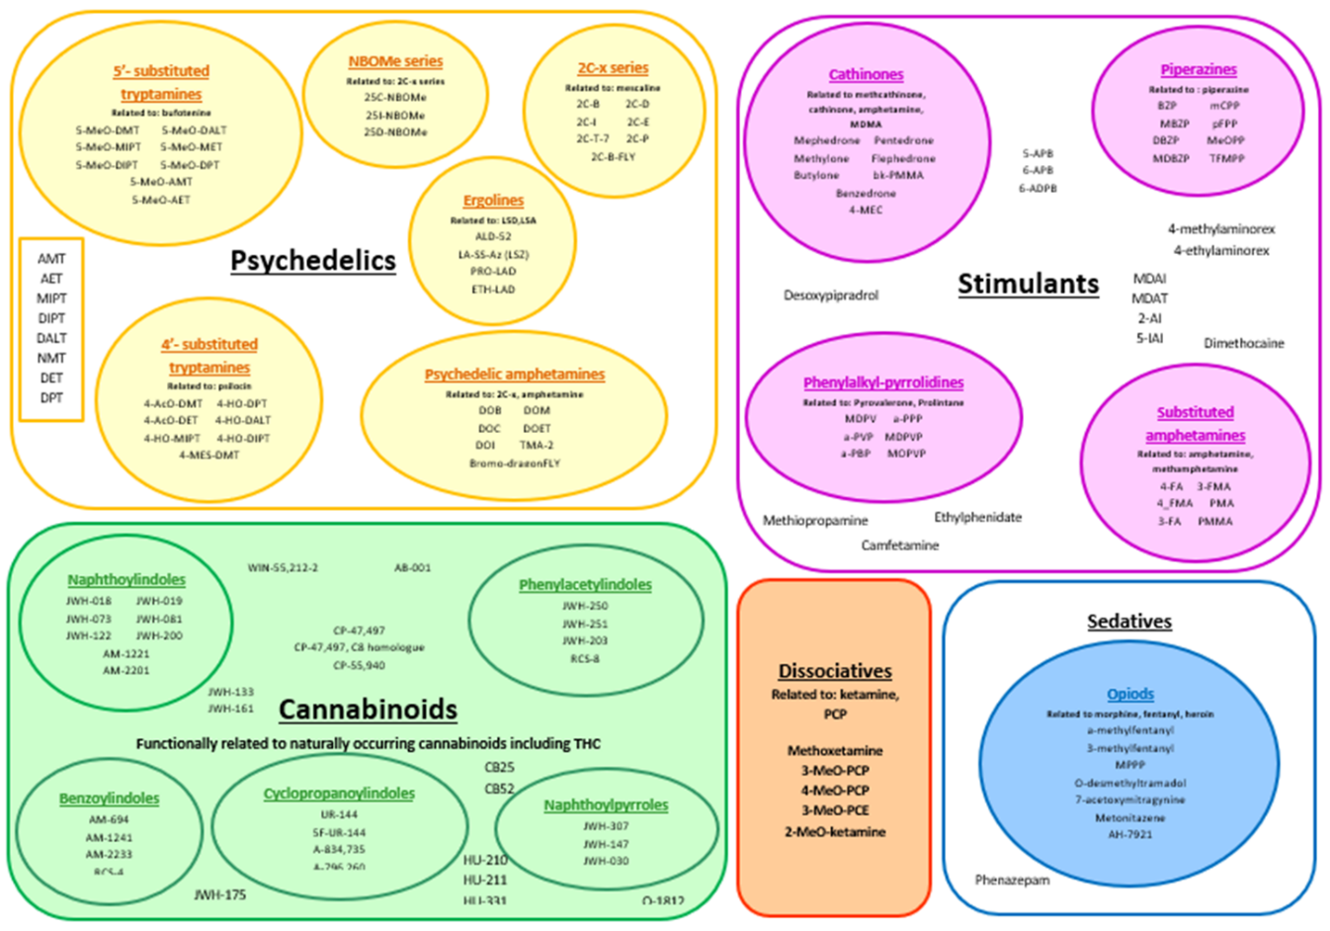
Notes:

Types of Drug Use
Notes:

Risks
Notes:

Who develops drug problems?
Notes:

Understanding who develops problems and becomes dependent – Background risk factors and the stages of adolescent development
Notes:

Addiction and Dependence
Notes:

Drug Problems can be diagnosed using the DSM-5 (manual for assessment and diagnosis of mental disorders) and the ICD-10 (the international classification fo diseases used to classify and code all diagnoses, symptoms and procedures in healthcare). 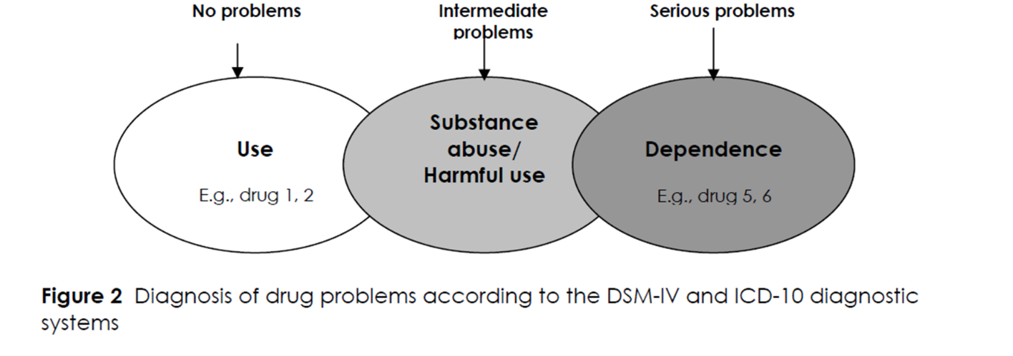
Dependence, ‘Motivation’ & Change – Prochaska & DiClemente
The cycle of change:
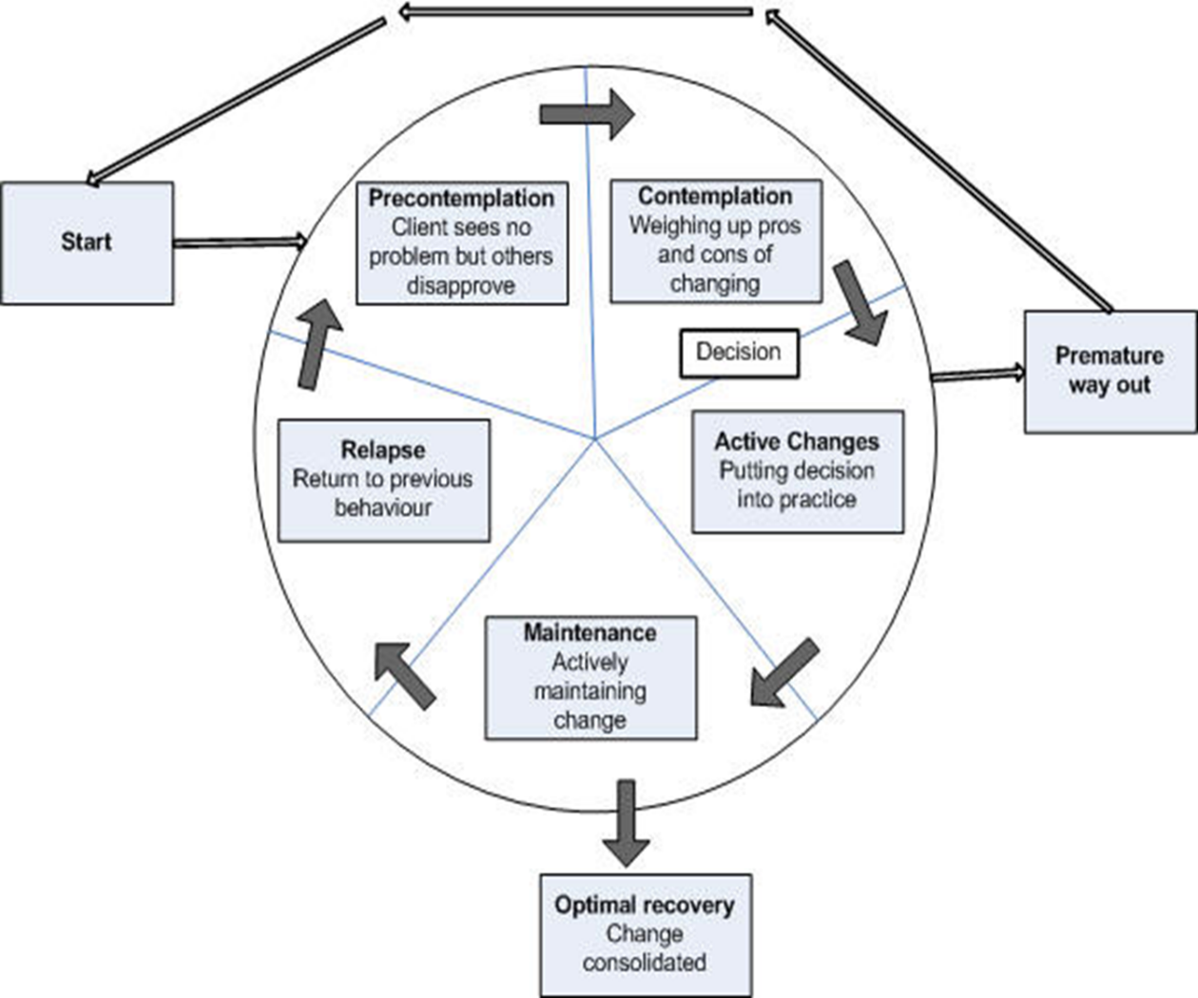
What help is available?
Notes:

Useful Resources:
We Are With You 0333 2000 325
YZUP 01872 300816
www.wearewithyou.org.uk

- www.cornwall.gov.uk/drugsandalcohol
- www.safercornwall.co.uk
- https://kfx.org.uk/
- www.drugsandhousing.co.uk
- www.erowid.org

Further Training
- Dual Diagnosis – mental health, drugs & alcohol
- Motivational Interviewing
- Mental Health First Aid
- Substance Misuse Screening with Young People
- Identification and Brief Advice (IBA)– Alcohol
- Blue Light Training – Working with Treatment Resistant Drinkers

